**Hands on with the first bendy phone - BBC News** ( 8/01/2019)

https://www.youtube.com/watch?v=12ByLAeGX6w

Royole is heading to the CES tech trade show in Las Vegas to show off the world's first commercially available flexible phone. A "developer's version" of the handset was put on sale late last year, beating more established device-makers to the punch. BBC Click's Dan Simmons tried the device and shared his thoughts.

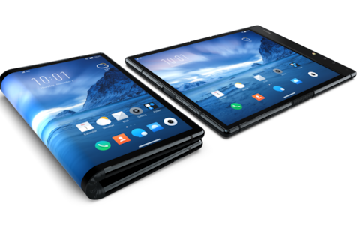

**1. Watch the video and answer the questions.**

1. Why is this smartphone unique? Because this phone can into to be a tablet. You can bend it (doblar)
2. How long has it been in production? 5 years
3. Is it light? It is very heavy
4. What OS does it run on? Android
5. How many times can it be folded and unfolded? Tens of thousand
6. Can specific apps use that feature?

**2. Watch the video again and complete the missing information.**

I got chance to use the world’s first flexible smartphone. It folds out into a tablet, as well, and that’s the secret of it. It’s **called** the Flex Pai and it’s been five years in production from a company called Royale. So what’s it like to **handle**? Well, it’s quite heavy if I’m being honest with you and it feels a little bit **bulky** putting it in your pocket, putting it anywhere basically. It’s a little bit more bulkier than perhaps a normal regular phone would be.

But just like something new in your hand that’s **shiny** and **slick** you wanna play with it all the time**, FLIP IT OVER** and that’s okay because the OS that runs on top of the Android system it uses -they call it water- automatically changes the screen, so you can have it one way and then **flip it around** and use it the other way. The screen flips with you, takes a little bit of time to resolve when those changes of screen happen between the tablet and the phone when you fold it.

I **wonder** how many times you can actually fold that screen before it breaks. They say they’ve done the **resilience** testing. We’re talking about tens of thousands of times that you can do it. That’s what they say. We’ll have to see if that works in practice. At the moment, the browser and the existing apps that er… come with Android are on it and they do work with the flexibility of that screen. But specific apps that use that feature, well, they are thin on the ground, I didn’t see anyone’d shown any and that’s why a developer’s model is out at the moment to **encourage** people to start programming for this unique aspect of the device.